**Ambassador Matsunaga Signed the Exchange of Notes (E/N) for The Yen Loan Project for implementing “the Lagos and Ogun Power Transmission System Improvement Project”**

On 15th December 2022, H.E. Mr. MATSUNAGA Kazuyoshi, Ambassador Extraordinary and Plenipotentiary of Japan to the Federal Republic of Nigeria, signed the Exchange of Notes with H.E. Zainab Shamsuna Ahmed, Honorable Minister of Finance, Budget and National Planning, to extend a Japanese Yen Loan for implementing “the Lagos and Ogun Power Transmission System Improvement Project” to enhance the transmission grid wheeling capacity in Nigeria. The Government of Japan has extended a Japanese Loan of JPY 26,180,000,000 (equivalent of 242.4 million USD) to the Government of the Federal Republic of Nigeria to promote the economic stabilization and development efforts of the Federal Republic of Nigeria.

This Japanese Yen Loan is aimed at enhancing the transmission grid wheeling capability and the stability of the electric power supply of the Federal Republic of Nigeria by installing and improving the transmission lines and substation facilities within Lagos State and Ogun State which are the industrial hub of the country, thereby contributing to the economic and social development of the Federal Republic of Nigeria. The loan will be made available through the Japan International Cooperation Agency (JICA) and the project will be implemented by the Transmission Company of Nigeria (TCN).

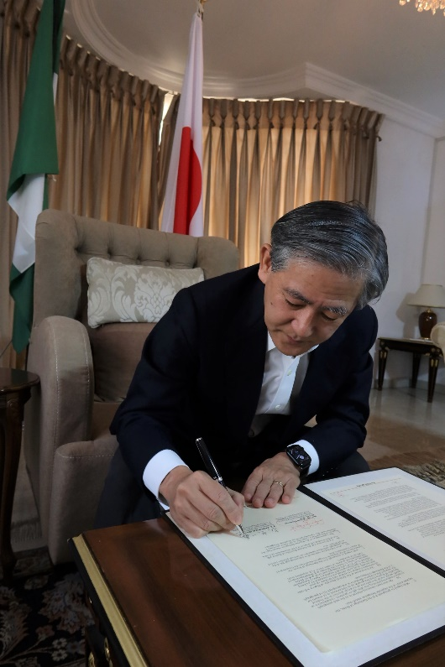For details, please see below:

|  |  |
| --- | --- |
| **Loan Amount** | Total amount of JPY 26,180,000,000 (approximately USD 242.4 million)  *Exchange Rate: USD 1= JPY108 |
| **Title** | The Project for Economic and Social Development Programme (The Lagos-Ogun Power Transmission Improvement Project). |
| **Scope of Works** | - Construction of Transmission Lines (total 215.5 km)  330 kV double circuit transmission lines: 110.1 km  132 kV double circuit transmission lines: 105.4 km  - Substation Construction  New construction: 6  Expansion: 3  - Consulting Services (Detailed Design for  transmission lines, Tender Assistance, Construction  Supervision, and Facilitation of Implementation of  Environmental Management Plan (EMP),  Environmental Monitoring Plan (EMoP) and  Resettlement Action Plan (RAP) |
| **Implementing Partner** | Transmission Company of Nigeria (TCN) |

